Chapter 2 - In Which Hans Remembers How it All Began

Hans could still remember the time before the war very clearly. He stored the images in his mind like snapshots and studied them from time to time in his thoughts.
In the morning you walked to school with your friends. School began at half-past seven and by then the sun was already strong. It finished at half-past twelve, then the children had to go straight home because that was when their hot meal was served. Rice, of course, with always a few different vegetables and kinds of meat. It was called a ‘rice table’. After that, Mum and Dad would go to sleep, which was normal in the Indies because it was too hot to do anything in the afternoon. The children were supposed to sleep then too, though they couldn’t of course. Staying quiet was enough. Hans always lay on his bed reading or did his homework. By three o’clock in the afternoon everyone was awake and kokki* Mina would bring tea and something sweet she’d made. Every household in the Indies had a couple of servants to do the laundry and keep the house clean. And a kokki for the cooking. The Netherlands was the boss of this territory, that was why it was also known as the Dutch East Indies. You call that a colony: a country with another country as its boss. The Indies were a long way from the Netherlands, in the tropics. Three hundred years ago, Dutch boats had landed there and conquered it. The Dutch lived in stone houses, the native population lived in bamboo huts on the edge of the city or in the countryside. They grew rice there or worked on the Dutch-owned plantations, or they were servants. They called themselves Javanese or Balinese or Madurese after the islands they lived or were born on. The whole of the native population were sometimes referred to as Indonesians. They were smaller than the Dutch, brown-skinned and mainly thin. They smiled a lot and were very helpful.
Hans’s family was lucky to have kokki Mina because she was a brilliant cook. She always brought a plate of kwee-kwee with the afternoon tea. Kwee-kwee means biscuits. But they could be made of anything: sweet black rice with coconut sauce, or kwee talam, that was a kind of pudding. Or roti koekoes, that was a warm, steamed cake. They were all really delicious, the things kokki Mina made while everyone slept. Father and mother always thanked her kindly for her trouble and Hans said ‘terima kassi’ or ‘thank you very much’. Once they’d satisfied their hunger, father and mother usually went to sit on the veranda to read. And Hans hurried off to search for neighbouring friends to play with: marbles, kiting or badminton. Or hide and seek, of course. They were happy times and now that Hans was so hungry in the camp, he often thought back to all those treats. Like the mothers in the camp, who always talked about good food and exchanged recipes. Strangely enough you felt less hungry when you thought about a nice meal. It was one of the reasons Hans still thought about those happy times a lot.
And they had lasted until the news suddenly came that the Netherlands was at war with Germany. There was a war in Europe, a big war. Germany against the rest of Europe and maybe even the rest of the world! The Germans had lost the first world war, a long time ago, and were still very angry about it, Hans’s father explained. And they had worked hard for years to get the best weapons and the best-trained army, so that they could take revenge. And now, in 1940, their army was strong enough. They wanted all of Europe and maybe Africa too.
The newspapers were full of it and you heard the news on the radio too. Hans’s father listened every day and his face became more and more gloomy. Neighbours dropped round to discuss what was happening in the motherland. The German troops were no joke, half of Rotterdam had been destroyed and they’d occupied the whole of the Netherlands in just a few days. And they were working on Belgium and France too. Only England was too far, there was a sea in the way. The Dutch queen had fled to England with her family. Some neighbours thought they were cowardly to escape, others thought them sensible. From England, they could encourage the Dutch to stay strong. Everyone was happy that the East Indies were so far away, the Germans couldn’t get there, even though there were German submarines in every ocean. But a submarine couldn’t capture a country. Luckily!
Still, Hans noticed that his parents were worried. Why?
Japan, a country near to the Indies, began to make threatening noises and had allied itself to Germany. Because Japan was an island which had gradually become too full of Japanese. They wanted to capture more ground and for years they had been busy training a large army and building airplanes and warships. Now that Germany was conquering Europe, those countries couldn’t protect their colonies because they needed their armies to fight off the Germans. In some places, like in the Netherlands, the armies had already surrendered to the Germans. Now Japan could try to occupy their colonies. The Dutch East Indies was on their list because the Dutch had turned it into a thriving colony and it had a plenty of oil under the ground. Japan really needed oil for its ships and airplanes.
Nevertheless, the people in the Indies weren’t really afraid of a Japanese attack.
‘My father says those Japs are incredibly squinty-eyed,’ Ronnie Eekhof, Hans’s best friend at school told him, ‘there’s no way they can shoot straight.’ It could be true, a Japanese photographer lived in the area and Hans had seen how slanted his eyes were.
‘And their tanks are made of tin,’ Ronnie continued, ‘you can dent them by just pushing on them. And their ships sink long before they get here.’
But things turned out differently.
One day, Hans’s father came home in completely different clothes than he normally wore. He had on a green uniform and a helmet. Only his glasses were the same, they had round lenses and black frames. His father always looked a bit surprised, Hans thought, but it could be because of the glasses. His mother ran to his father and kissed him longer than she usually did. They talked in a huddle for a while, so quietly that Hans couldn’t hear anything they said. But at last his father came over to him.
‘Son,’ he said, ‘your father’s going to fight the Japanese. Don’t be afraid, I’ll be back in a few days. And maybe they won’t even land on Java.’
‘Can I have a helmet too?’ Hans asked.
‘Well, ask kokki for an iron pan,’ his father said. ‘Listen, Hans, while I’m away, you’re the man of the house. Look after your mother and don’t be difficult or naughty. And listen to her! Do you promise?’
Hans nodded. He went to kokki Mina and asked for a wadjan. That was a deep, round frying pan with two handles. Mina had several and the smallest fit over his head. With an elastic tied around both handles and under his chin, the wadjan stayed firmly on his head, if he walked normally. If he ran, he had to hold onto it with his hand. But it was a helmet, Japanese bullets couldn’t go through it. Japanese bullets just burst apart when they hit metal, Ronnie had told him.

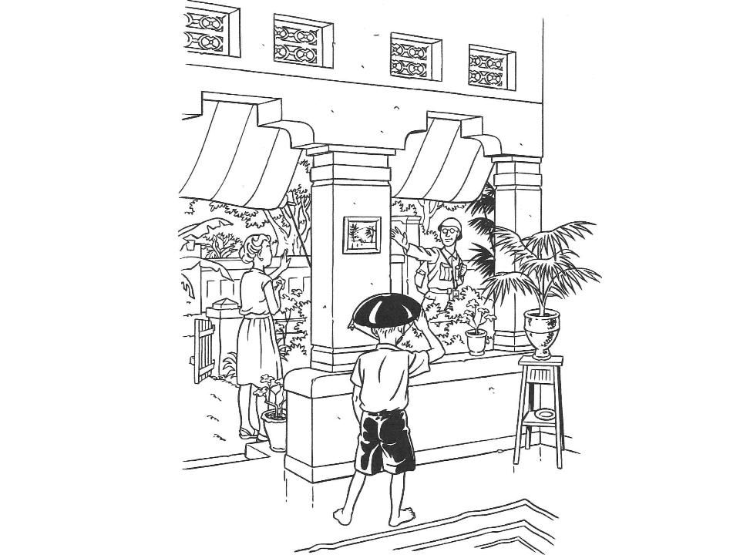

He’d been wearing the pan on his head all day but took it off to say goodbye. His father ruffled his hair. Hans hadn’t been keen on kisses for a long time, having his hair ruffled was still just about alright. Afterwards he put the wadjan back on his head and solemnly held out his hand to his father. Mother walked along with father and Hans heard her sobbing when he turned around again and waved.

* * *

‘Have you heard? The Japanese have landed!’ Ronnie cried a few days later. ‘Our army lost!’
‘Are they dead?’ Hans asked. In all the books he read about knights and knaves, the knights fought until they were dead or had killed the others. He didn’t dare think his father might be…
‘No, they surrendered,’ Ronnie said. ‘My father said they’re cowards. Scaredy cats. If he wasn’t so ill, he’d teach those slitty eyes some manners. My father said. But well…’
Ronnie’s father had suffered a malaria attack on the day he’d been called up to be a soldier. Hans knew malaria could make you very ill, because everyone in the Indies got it from time to time. It came from the mosquitoes that flew around everywhere and bit you wherever you went. Then something got in your blood and made you sick. Headache, nausea, Hans had already had it.
That was why he found it a bit strange when Ronnie’s father was just sitting in the garden reading his paper a day later when Hans went to call on his friend. Was Ronnie’s father really ill? But as soon as he saw Hans, he dropped his paper and called out in a weak voice: ‘Oh, Hans, could you fetch me a glass of water? I’m trying to read the news about the war, but I can’t with this terrible headache.’ And when Hans had fetched water for him: ‘Could you read out this bit? My eyes hurt.’ He was wearing pyjamas and squinted at Hans through screwed-up eyes. Ronnie’s father was a small, skinny man with thinning hair. It was hard to believe he had once been a boxing champion, but Ronnie swore it was true.
Hans took the paper and read the front page headline: ‘The attack on Java has begun. Enemy in Krawang area. Our army expected to launch counter-attack.’
‘Oh,’ Ronnie’s father said, ‘never mind. Old news. The Japanese tanks are already heading our way, to Soerabaja, I heard it on the radio. Go and find Ronnie.’
Hans found Ronnie in the backyard making a catapult. You needed a small stick with a V-shape at the end. A strong piece of elastic fixed around it and you could fire small stones.
‘If you go and find some stones, we’ll have a weapon against those Japs,’ he said.
‘Why stones? I’ve got some marbles,’ Hans said. He was good at playing marbles and had lots of them.
Ronnie looked up. ‘That’s a good idea,’ he said, ‘ but don’t you think it would be a waste of marbles?’
‘Not at all, when you’re ready I’ll go get them.’
A few days later they were sitting behind the wall in the front garden watching the Japanese enter the city.
They walked in two rows behind each another, guns on their shoulders, green uniforms and green caps. The men were short, even shorter than most locals, and they were already shorter than the Dutch. A Japanese carrying a flagpole walked up front. The flag was white, with a red ball on it.
The long row stopped, maybe they needed to ask the way. In any case there was some loud shouting and the Japanese soldiers stood at ease.
Some of them yawned, others stretched. They talked amongst themselves, but it sounded more like shouting than talking. It was a hard, ugly language.
They saw a woman who lived a few houses further come outside.
She walked up to the Japanese and asked something.
The soldier bowed slightly and gestured to her: bow!
The woman shrugged and turned around. The soldier remained in his row, but a higher ranking one came along. He stopped the woman and hit her on the face with the back of his hand.
She started screaming and he barked a few words of Japanese at her.
Only once she’d made a slight bow did he let her go.
‘Did you see that?’ Ronnie asked, but Hans didn’t reply. Of course he’d seen.
Ronnie got out his catapult, aimed at the Japanese and strung it.

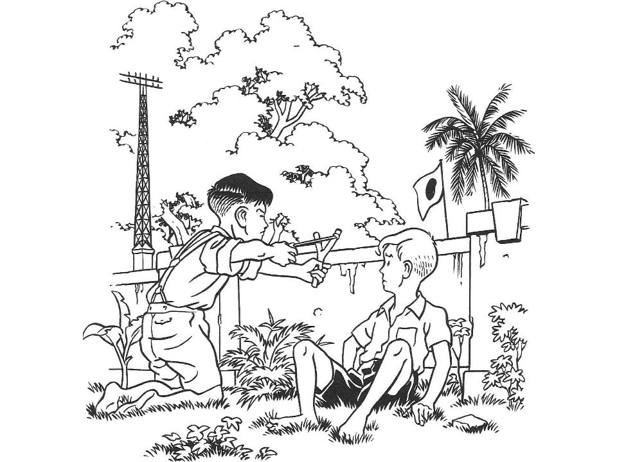

Hans knocked Ronnie’s hand just in time for the marble to fly over the Japanese and into a tree. You heard a soft tap and then the marble fell down. The Japanese picked it up and put it in his pocket. He looked around but Hans and Ronnie didn’t wait for him to spot them and ducked quickly behind the front garden wall. Ronnie hurriedly hid the catapult in the sand. The din made by the Japanese soldiers was silenced by an order. After that they heard the sound of boots marching and sighed with relief.
‘You’re so stupid!’ Hans cried to Ronnie, ‘what made you aim for that man? Those people have got guns!’
‘You’re right, I didn’t think,’ Ronnie said. He was still pale from the fright.

Words in italics are explained at the back of the book

